Analysing the Network of Aged Care Hospital Transfers in Victoria

Student Name: Lesheng Xu

Student ID: 29615550

Email: lxuu0021@student.monash.edu

Supervisors:  
- Dr Michael Lydeamore   
- Prof Di Cook

# Abstract

This study investigates the network of transfers between aged care facilities and hospitals in Victoria using data from Ambulance Victoria. The analysis combines exploratory data techniques with statistical modelling to understand structural patterns and temporal variations in transfers. The network shows a highly centralised structure, with major hospitals and a small number of aged care facilities acting as key hubs. Transfers were significantly lower during weekends and declined further during the COVID-19 period, although the impact varied across facilities.

To model transfer behaviour, we compared several approaches and found that the negative binomial generalised linear model provided the best fit. This model accounted for overdispersion in the data, delivered stable predictions, and outperformed the Poisson model across multiple evaluation criteria. Cross-validation confirmed that predictive accuracy was consistent over time, with only minor biases in specific subgroups.

The results highlight the strong heterogeneity of aged care transfers, both across facilities and over time. They provide practical insights for staffing, ambulance planning, and infection control, particularly by identifying high-volume transfer corridors and weekday–weekend differences. The study also reveals data challenges, including inconsistent facility classification and the absence of richer covariates such as distance or clinical factors.

This work demonstrates that network-informed modelling of aged care transfers is both feasible and informative. The findings provide a foundation for more comprehensive models and simulations, which can strengthen public health planning and improve the resilience of aged care systems.

# Background

The transfer of residents from aged care facilities to hospitals is a common and necessary component of eldercare. These transfers occur for a variety of reasons such as urgent medical treatment, regular medical appointments, and preventative health care. They also occur to prevent or manage outbreaks within facilities by removing vulnerable residents to reduce transmission risks. Although medically justified, these transfers may pose significant risks, particularly with respect to the spread of infectious diseases. Older adults are more susceptible to infections, and their frequent transfers between facilities and hospitals potentially create a vector for disease transmission across sites.

Aged care networks form complex systems in which facilities are nodes and patient transfers are links. Epidemiological and network studies have shown that patient movement in such systems can influence the spread of diseases such as influenza and MRSA (Donker et al., 2010; Assab et al., 2017). However, this dynamic has not been rigorously studied in the Australian aged care context, particularly within Victoria. Given the sector's vulnerability during recent infectious outbreaks, including COVID-19, a deep understanding of these inter-facility connections is both timely and necessary.

# Motivation

The Australian aged care sector, especially in Victoria, was severely impacted during the COVID-19 pandemic. Infections were often introduced and amplified through transfers between aged care facilities and hospitals. This research is motivated by the need to understand how transfer patterns contribute to this problem.

While research has addressed hospital networks and general healthcare systems (Donker et al., 2010), a gap exists in the context-specific analysis of aged care in Victoria. Further, there is a need to move beyond descriptive studies and toward predictive models that can inform practical interventions. Insights from this research can guide policy on managing transfers, preventing outbreaks, and improving aged care outcomes, especially for infection control.

This proposal aims to fill this gap using network science and epidemiological modelling, with the potential to impact public health policy, hospital logistics, and aged care management.

# Research Questions

1. **What are the structural properties of the network formed by patient transfers between aged care facilities and hospitals in Victoria?**
2. **Can the impact of COVID-19 be detected in the network?**
3. **What is the most appropriate model fit for the transfer network within the project scope?**

# Review of the Literature

Healthcare network analysis has gained attention as a method to understand and potentially curb the spread of infectious diseases. Donker et al. (2010, 2012) and Assab et al. (2017) demonstrated that patient transfers between healthcare institutions can significantly influence infection dynamics. They used network analysis metrics—such as centrality, clustering, and modularity—to uncover key institutions that act as hubs or bridges for disease propagation.

Although similar methodologies have been applied in the United States and Europe, the literature remains sparse in the Australian context. Moreover, the aged care sector presents unique challenges compared to hospital settings, including higher baseline vulnerability, longer stay duration, and limited infection control resources.

Various modelling approaches, such as agent-based simulations and stochastic processes, have been used to simulate disease spread within healthcare systems (Pei et al., 2018). These techniques help assess different outbreak scenarios and intervention strategies such as reducing specific transfers or vaccinating key nodes. However, their application in Victorian aged care remains unexplored.

This study builds on the existing body of work, and will contextualize findings within the Australian aged care system using data from Ambulance Victoria.

# Research Methodology

This study aims to model and analyse the inter-facility patient transfer network between aged care facilities and hospitals in Victoria using transfer data from Ambulance Victoria. We will explore and evaluate several candidate models for fitting and explaining the observed network, such as the gravity model, spatial interaction models, and network regression frameworks. Model selection will be based on empirical fit, interpret-ability, and suitability for potential downstream applications such as infectious diseases modeling.

## 1.Data Source:

The study will use anonymized patient transfer data from Ambulance Victoria, detailing origin and destination facilities, timestamps, and patient identifiers (unique ID).

2.Ethical Considerations:  
Patient data will be anonymized and used in compliance with Alfred Health ethics guidelines and health data protection standards. Approval has been sought from the Alfred Health ethics committee.

## 3.Network Construction

The study will construct a directed and weighted network to represent patient transfers between aged care facilities and hospitals. In this network, each node corresponds to either an aged care facility or a hospital, while each edge represents the flow of patients, directed from the origin facility to the receiving hospital. The weight of each edge reflects the frequency of transfers over a defined time window, such as quarterly or annually, allowing for temporal flexibility in analysis. The network will also be stratified by specific time periods, including the onset of COVID-19 beginning on 15 March 2020, as well as by weekdays and weekends, to capture variations in transfer behaviour. This structure supports the use of network analysis techniques and enables the estimation of statistical models of link formation and intensity. Visualization and analysis will be conducted using R, employing packages such as igraph, tidygraph, and ggraph to generate clear and interoperable network representations.

## **4.**Candidate Modeling

To explain and predict the observed patterns in transfer flows, the following modeling strategies will be considered: 1. Gravity Model. 2. Stochastic Block Models. 3. GLM...

## **5.**Model Selection and Evaluation

The process of selecting and evaluating models will consider statistical, practical, and contextual factors. Goodness-of-fit will be measured using deviance, log-likelihood, and RMSE on holdout data. These metrics will provide a benchmark for how well each model captures the observed transfer patterns. Interpretability will also be important. A model must not only achieve good statistical performance but also explain the main drivers of transfer volumes in a clear way. Predictive performance will be judged by how well a model can forecast behaviour under unseen conditions. Scalability will be checked to ensure that methods remain feasible when applied to statewide data. Applicability will also guide evaluation, with preference given to models that can support future extensions such as infection spread simulations.

To ensure reliable results, evaluation will use complementary methods. Cross-validation and bootstrapping will test the stability of the findings and confirm whether results remain consistent across different subsets of the data. Network diagnostics, including centrality, degree distribution, and modularity, will add further insight into the structure of the transfer system. These diagnostics not only validate statistical adequacy but also highlight important structural properties that explain network behaviour. Taken together, these criteria and methods will ensure that model selection is both rigorous and relevant to the aged care context.

# Exploratory data analysis

##### Age and gender

The histogram of age has majority of patients are between 80 and 95 years old, reflecting a population from Residential Aged Care Facilities (RACFs). The right-skewed distribution suggests most patients are elderly, with fewer younger individuals. Young age tail (ages 0–50) likely includes data anomalies or misclassified visitors, staff, or newborns, and may be required for analysis focused purely on aged care and filtered out depending on the network presentation.

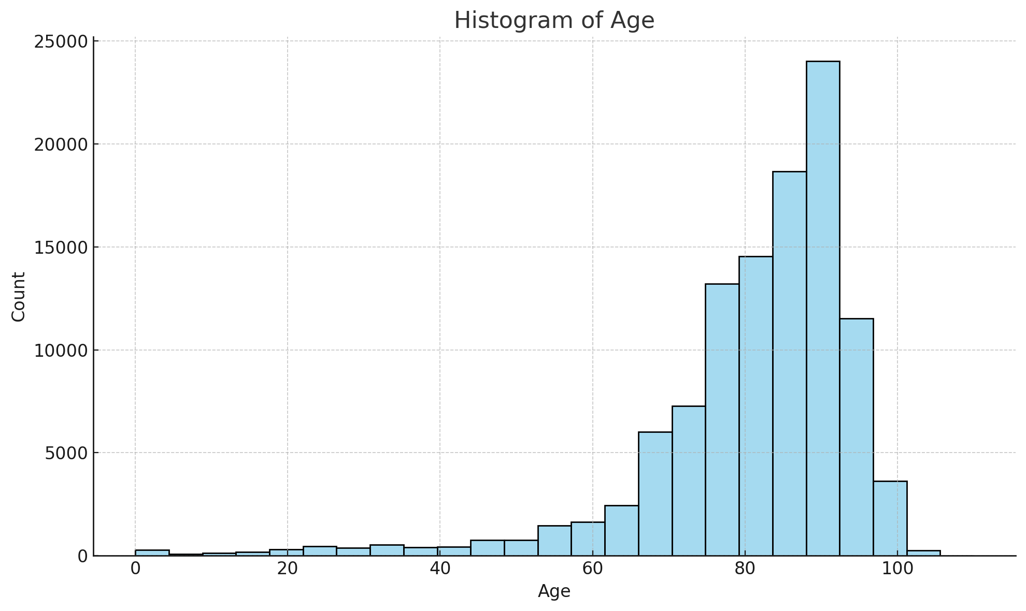

*Figure 1: Histogram of age allocation*

Female Predominance (~57%) is consistent with demographic patterns in aged care populations. Women have higher life expectancy, leading to more elderly females in Residential Aged Care Facilities. Many residents requiring care for chronic, degenerative conditions are female. Male Proportion (~43%) indicates a [substantial](https://www.thesaurus.com/browse/substantial) cohort of older males accessing ambulance services. Male residents may differ slightly in clinical profiles such as more cardiac or trauma-related transfers, though that would require deeper diagnosis comparison. 36 cases entries marked as "Indeterminate" is likely due to data entry errors or edge cases involving gender identity not captured in binary format. Given the tiny proportion, it does not significantly affect analysis, but could be flagged for completeness.

##### Diagnosis and Case Nature

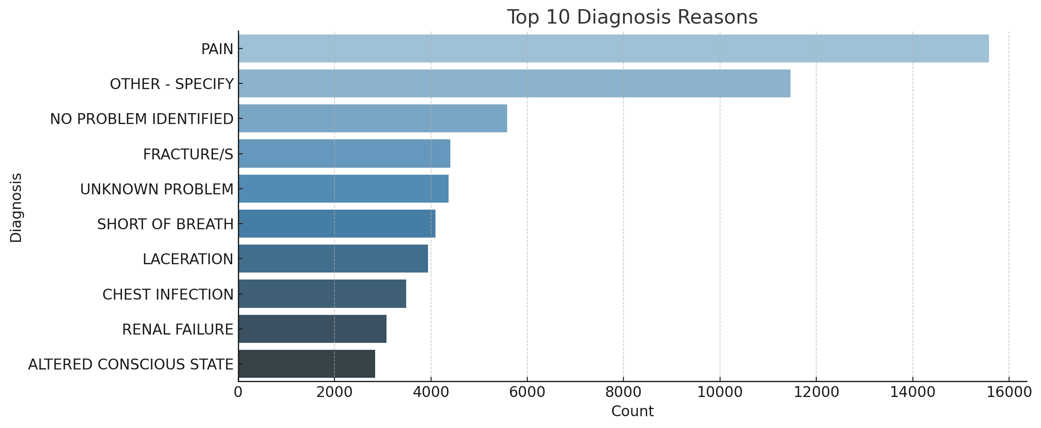

*Figure 2: Top 10 Diagnosis Reasons*

The most common diagnosis - pain , reflects frailty and chronic illness in elderly patients. A significant share of cases involve ambiguous or unspecified issues, suggesting diagnostic complexity in this population. Many are trauma or fall related, like fractures and lacerations, underlining fall risk in aged care settings. Respiratory and renal diagnoses align with known comorbidity in aged care residents.

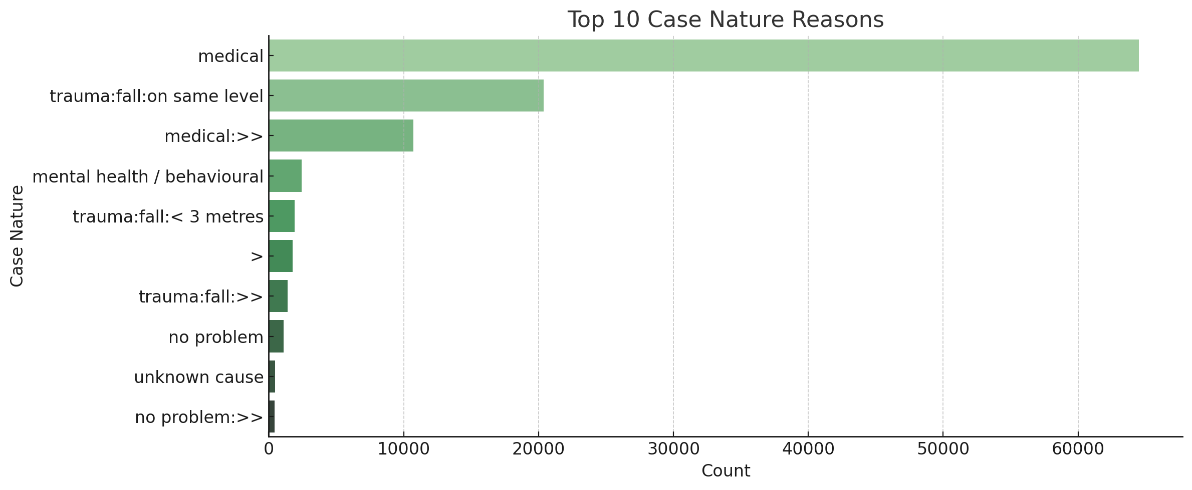*Figure 3: Top 10 Case Nature Reasons*

The overwhelming lead of “medical” nature confirms the dataset's focus on internal, chronic, or age-related conditions. Falls (on the same level or <3 meters) are a major concern, collectively making up ~25,000 records, consistent with the injury/frailty patterns in aged care. Several entries (e.g., “>>” or malformed text) suggest dirty or inconsistent data, which may need cleaning or reclassification for reliable statistical analysis.

Many patients present with vague symptoms, making definitive diagnosis difficult at scene level. Pain, breathing issues, altered consciousness, and fractures dominate diagnosis patterns, which is the key concerns in frail elderly populations. Falls are a huge contributor to emergency response and hospital transfers, both by diagnosis (fractures, lacerations) and case nature. The presence of ambiguous and malformed entries highlights the importance of data cleaning before advanced analysis.

##### 1.3 Transfers

General transfer counts has total records of 109,415. The full set of transfers recorded in the data set, covering multiple years and all types of transfers.

Pre-COVID Transfers (Before March 2020): 52,119

These are transfers that occurred before the pandemic began impacting healthcare systems in Victoria, which represents about 47.6% of the data set.

During-COVID Transfers (March 2020 Onward): 57,296

Despite pandemic disruptions, transfer activity did not decrease dramatically overall. In fact, the number is slightly higher. This increase could be due to changes in hospital admission procedures, discharges from aged care during outbreaks, or system configurations.

| Period | Transfers | % of Total |
| --- | --- | --- |
| Weekdays | 83,175 | ~76% |
| Weekends | 26,240 | ~24% |

*Table 1: Weekdays vs Weekends transfer counts*

Transfers between weekdays and weekends are heavily skewed toward weekdays, which makes sense operationally. More hospital staff and admin are available during weekday and routine and inter-hospital transfers are usually scheduled during business days. Weekend transfers are likely more urgent or emergency-related. However, the number of days are different for the two category, a standardized transformation is necessary for further pattern analysis.

| Day | Count | Remark |
| --- | --- | --- |
| Friday | 17,419 | Highest volume – likely due to clearing patients before the weekend. |
| Wednesday | 16,864 | Mid-week, stable scheduling. |
| Thursday | 16,504 | Similar reasons as Wednesday. |
| Monday | 16,446 | Start-of-week scheduling resumes. |
| Tuesday | 15,942 | Slightly lower, but consistent. |
| Saturday | 13,690 | Weekend begins – reduction in routine transfers. |
| Sunday | 12,550 | Lowest – possibly only emergency or critical transfers. |

*Table 2: Day-of-Week breakdown from highest to lowest*

The decline from Friday to Sunday suggests planned transfers slow down on weekends, which is similar to previous comparison.

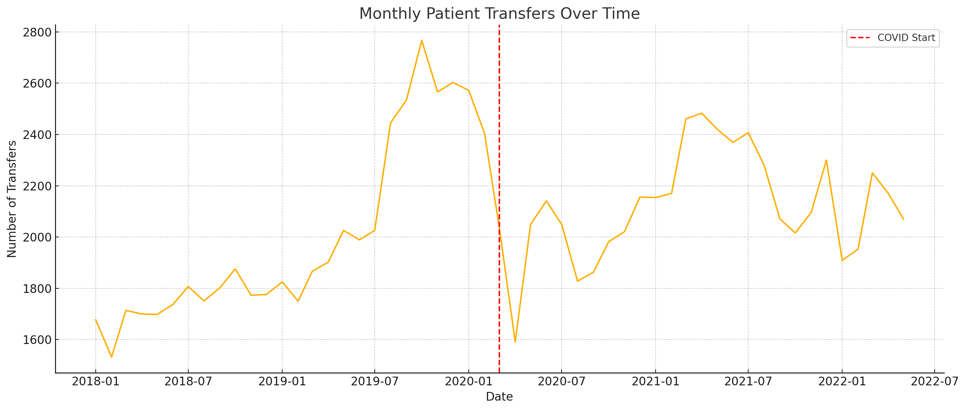*Figure 4: Monthly transfer trend*

The plotted line graph shows a steady number of transfers before March 2020. The visible dip starting March 2020, indicating the immediate impact of the COVID-19 pandemic.

This likely coincides with initial lock-downs, policy shifts restricting movement, or because of hesitation in transferring elderly patients due to infection risk.

Recovery or plateau phases can be seen later in 2020–2022 as systems adjusted (e.g., protocols for safe transfer, vaccinated populations, etc.).

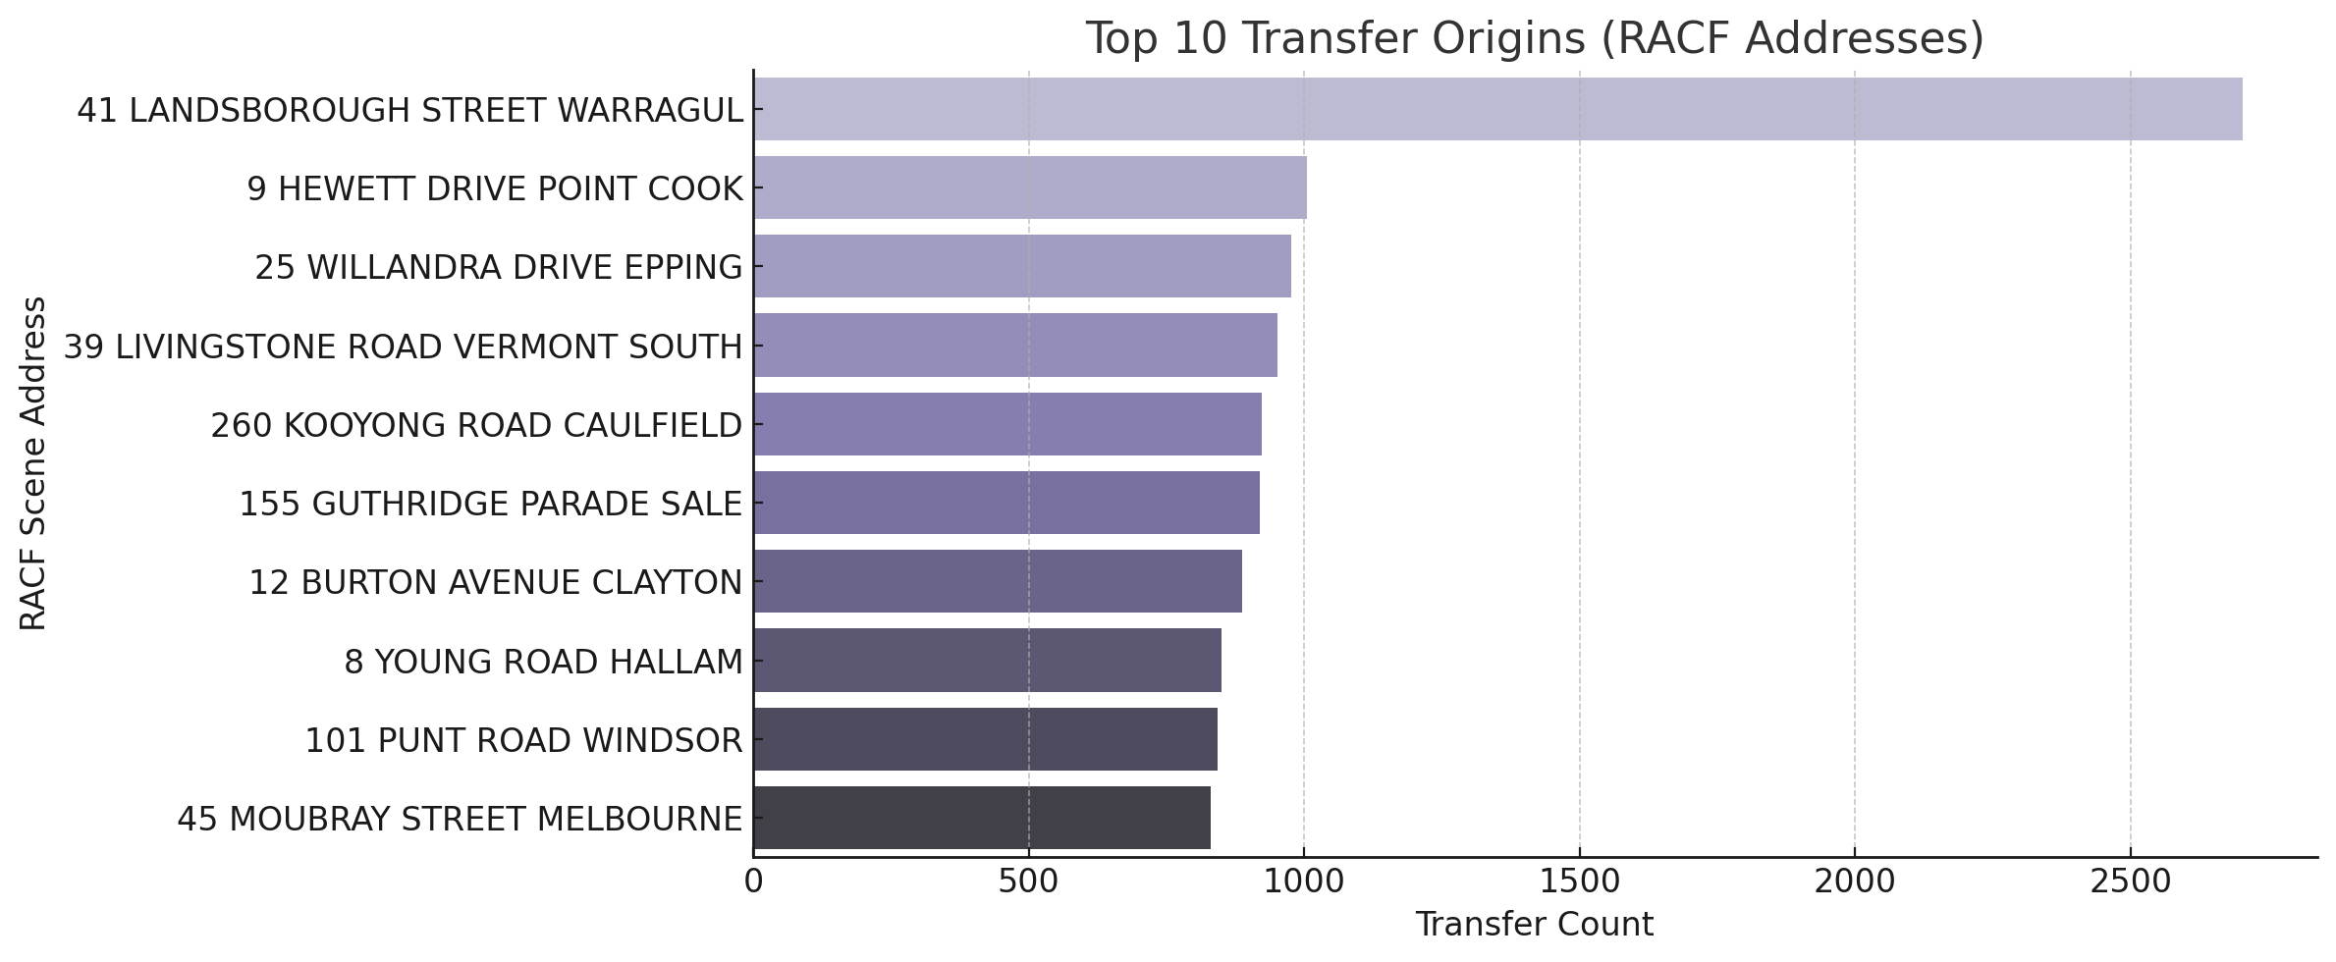

*Figure 5: Top 10 transfer origins*

These addresses represent large and high-needs aged care facilities, with frequent transfers to hospitals.

The very high number at Landsborough Street, Warragul is not a Residential Aged Care Facility (RACF), but rather the address of West Gippsland Hospital, a known public hospital in Victoria. By filtering, 1699 out of 2704 transfers are identified as inter-hospital transfers. Therefore, the address can be treated as hospital. This case illustrates why cross-verifying fields like “sceneaddress”, “category”, and “iht” from the dataset is crucial when identifying RACF-related flows.

Regional sites like Sale and Warragul show significant activity, suggesting strong ambulance dependency in non-metropolitan areas.

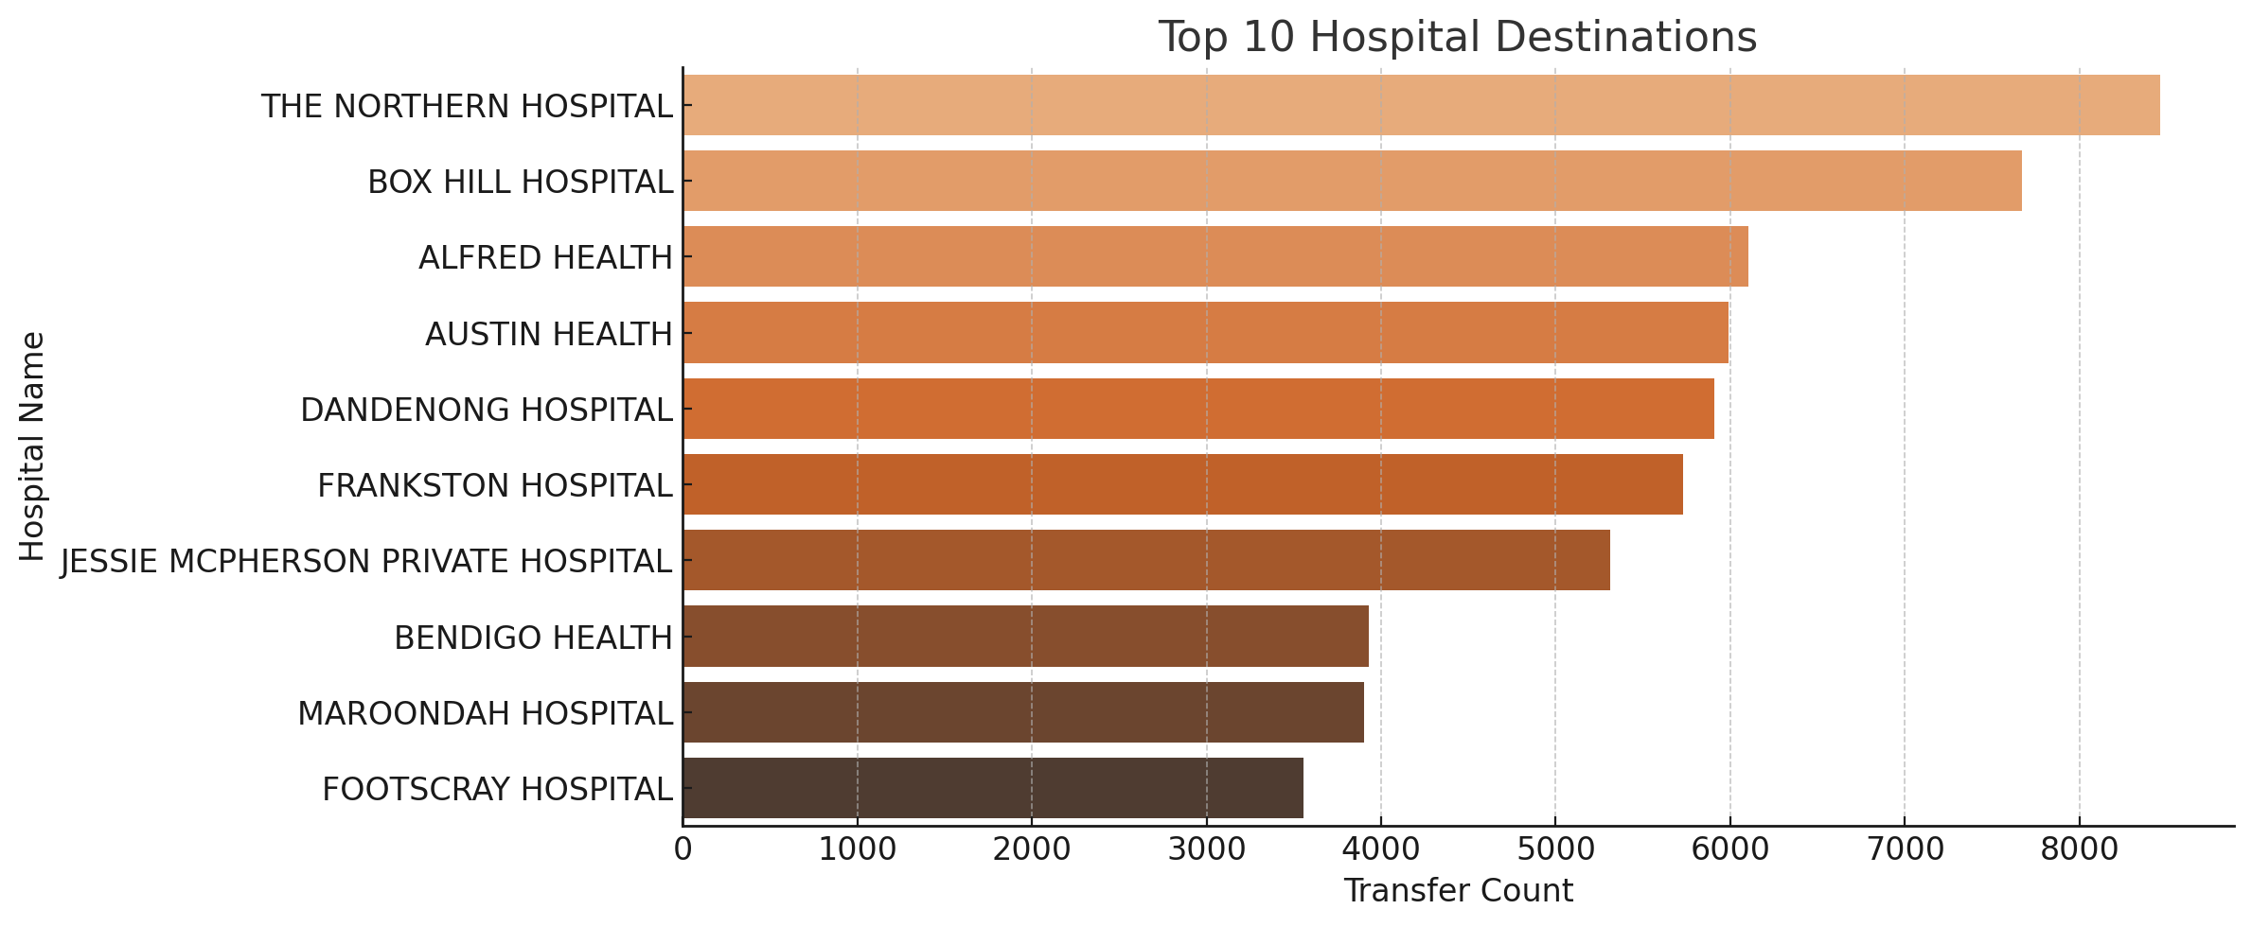

*Figure 6: Top 10 hospital destinations*

These hospitals are all major metropolitan or regional centres, serving large populations and multiple RACFs in their catchment area.The Northern Hospital and Box Hill Hospital top the list, indicating large volumes of aged care in surrounding suburbs (e.g., Epping, Heidelberg, Bundoora) and also well-connected ambulance referral networks

Private facilities like Jessie McPherson also appear, hinting that some RACF residents are privately insured or transferred based on GP/contractual relationships.

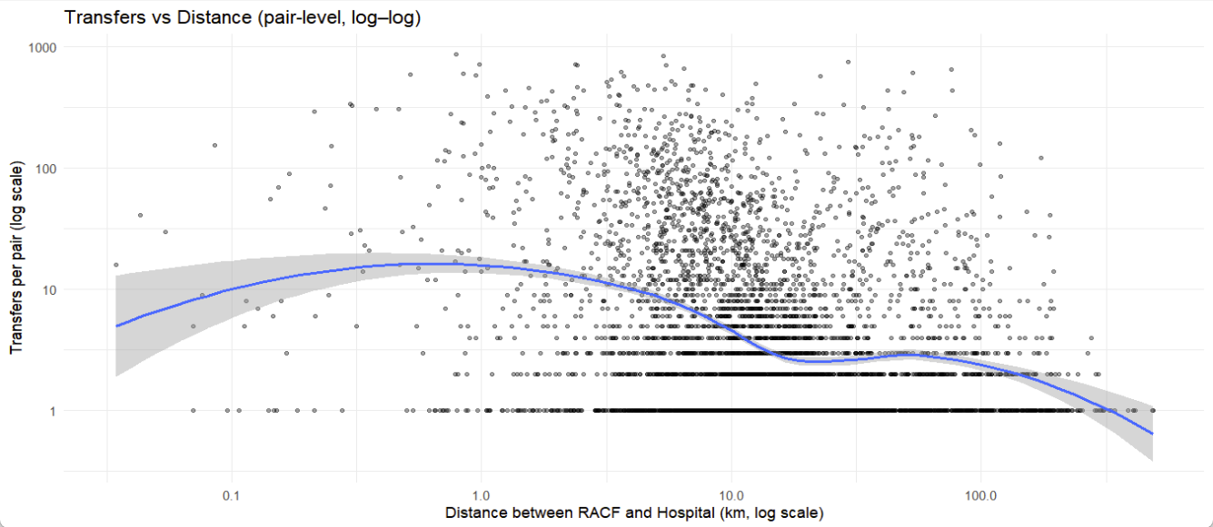

*Figure 7: transfers vs distance*

Looking into the relationship between distance and transfers, the exploratory plot Figure 7 relates pair-level transfers to straight-line distance on log–log axes. The smooth shows a weak rise at very short distances, a short plateau around one kilometre, and a clear decline beyond roughly five to ten kilometres. This pattern is consistent with distance friction but is not monotone. Variance increases with distance and is large across the range. Many pairs record only one transfer, which creates a visible floor on the log scale. The confidence band widens at the extremes, indicating sparse data and unstable estimates. These features suggest a complex and non-linear relationship that a simple linear term would mis-specify.

# Network Analysis

*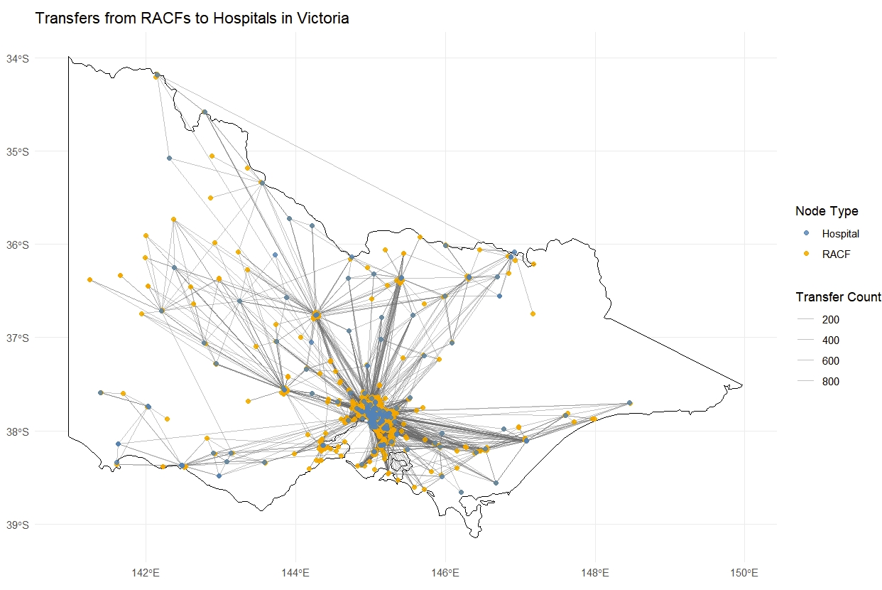Figure 8: Network Visualization*

Figure 8 visualizes the directional flow of patient transfers across the state, connecting RACFs (yellow nodes) to hospitals (blue nodes) using geospatial coordinates. Each node’s size represents the volume of transfers, while edge thickness reflects the frequency of movement between each RACF and hospital.The plot demonstrates a strongly centralized structure, with dense connections concentrated around Melbourne's metropolitan area. Numerous RACFs link to major hospitals like the Northern, Alfred, Box Hill, and Austin, marking these as key hubs for aged care admissions. In contrast, rural and regional RACFs appear more isolated, typically connected to single hospitals over greater distances, which highlights rural areas' reliance on limited healthcare facilities.

The map also reveals critical transfer corridors and regional dependencies, with some lines extending far across the state, implying longer transport times and possible challenges in accessing timely care. Ultimately, the network plot clearly visualizes both the urban-centralized nature of aged care transfers and the geographic disparities affecting remote Victorian RACFs.



*Figure 9: Fish-eye network of transfers over Victoria*

The fish-eye transformation magnifies Melbourne's metropolitan region, where most RACF-to-hospital transfers are concentrated. Meanwhile, it compresses rural areas to minimize visual clutter, highlighting the network's core activity in Figure 8. This distortion highlights the intricate web of connections among major hospitals and RACFs that would otherwise overlap in a standard geographic plot. This enables clearer identification of transfer hubs, corridors, and high-demand facilities. The fish-eye view sacrifices precise geographic fidelity for enhanced clarity, directing attention to high-traffic transfer hubs. This approach better reveals key patterns—hospital bottlenecks, RACF reliance, and overlapping service zones, which demands analytical focus. This transformation is particularly useful for healthcare network analysis because it balances clarity with spatial context, supporting better recognition of operational bottlenecks and urban transfer dynamics while still retaining the overall structure of the network across Victoria.

##### 2.1 Network comparison

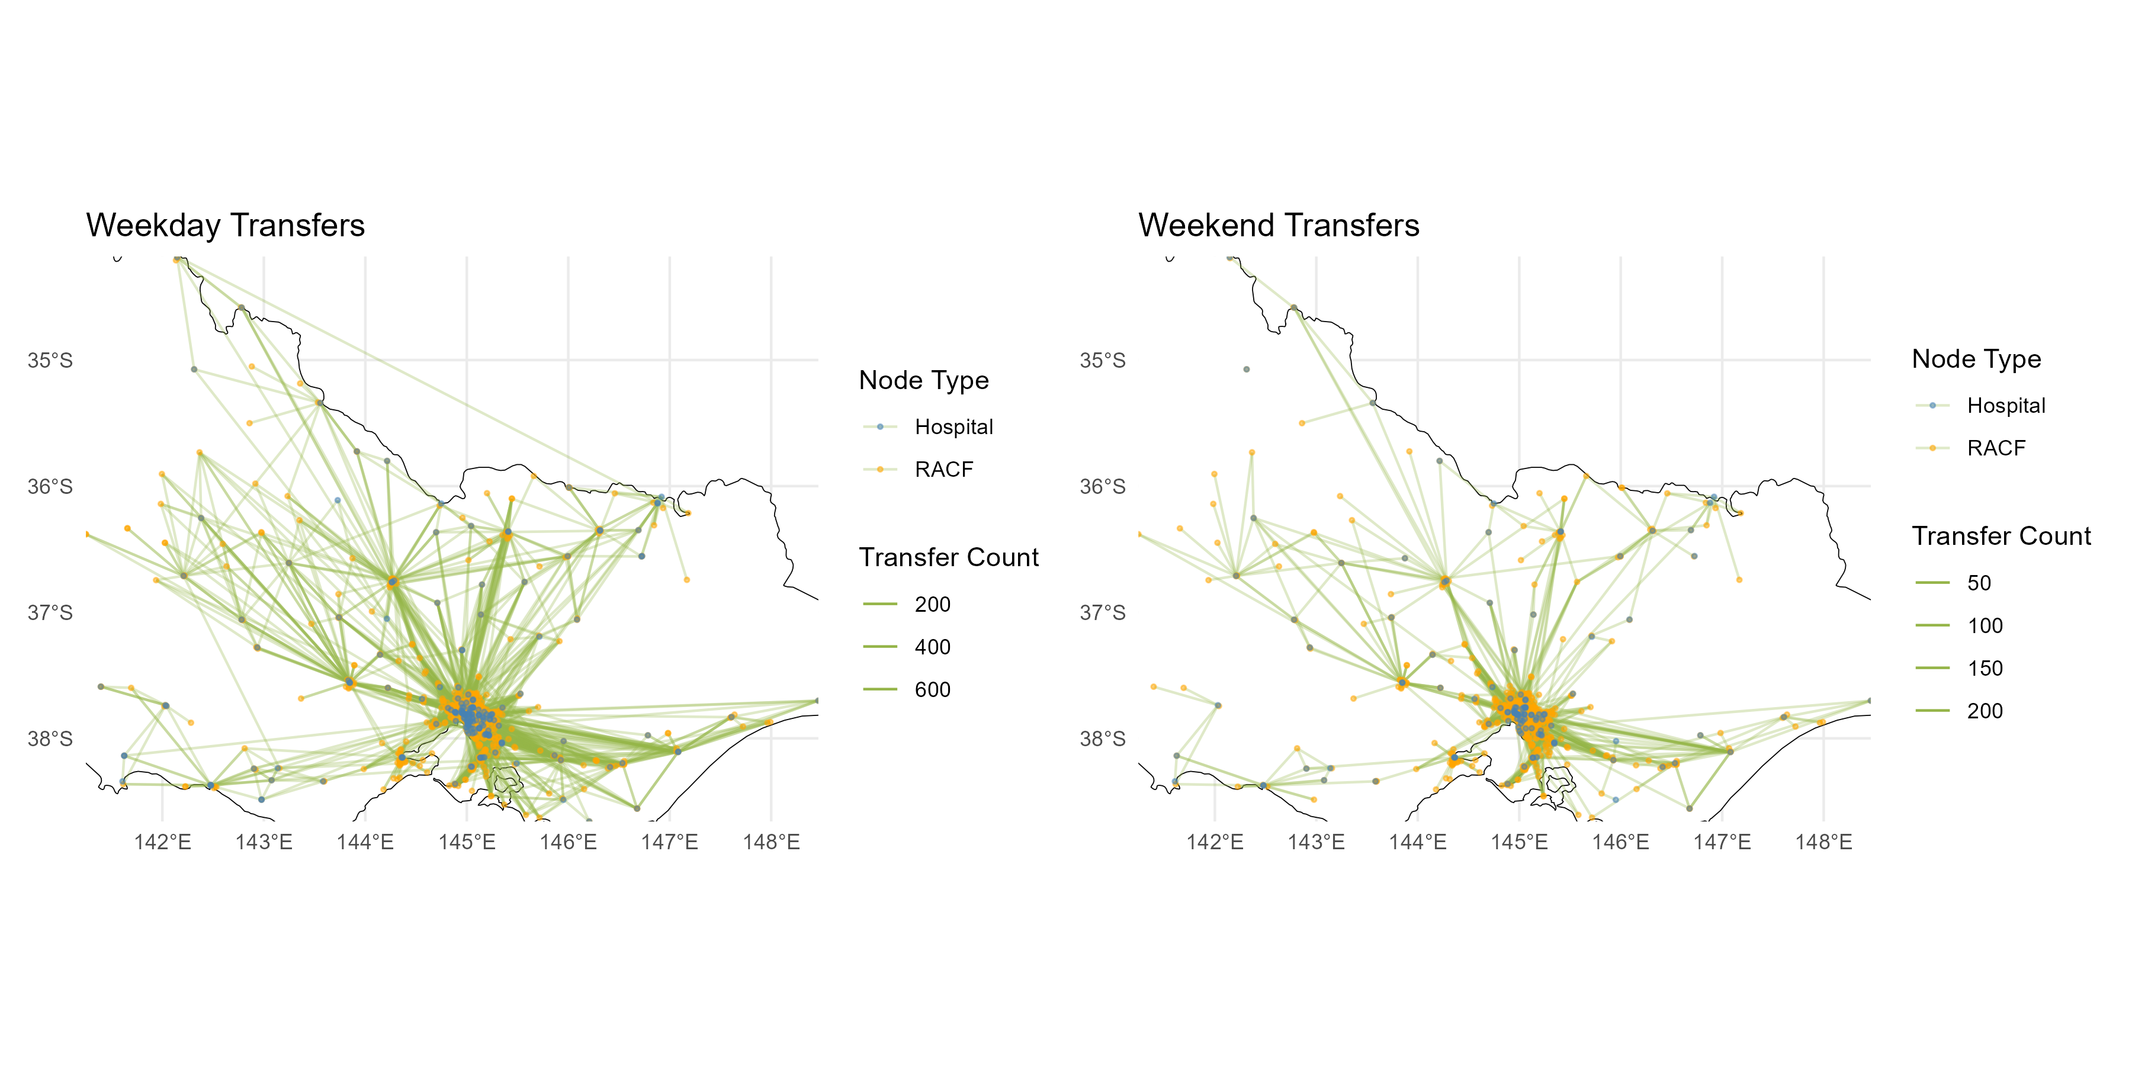

*Figure 10: Comparison of transfer network between weekdays and weekends*

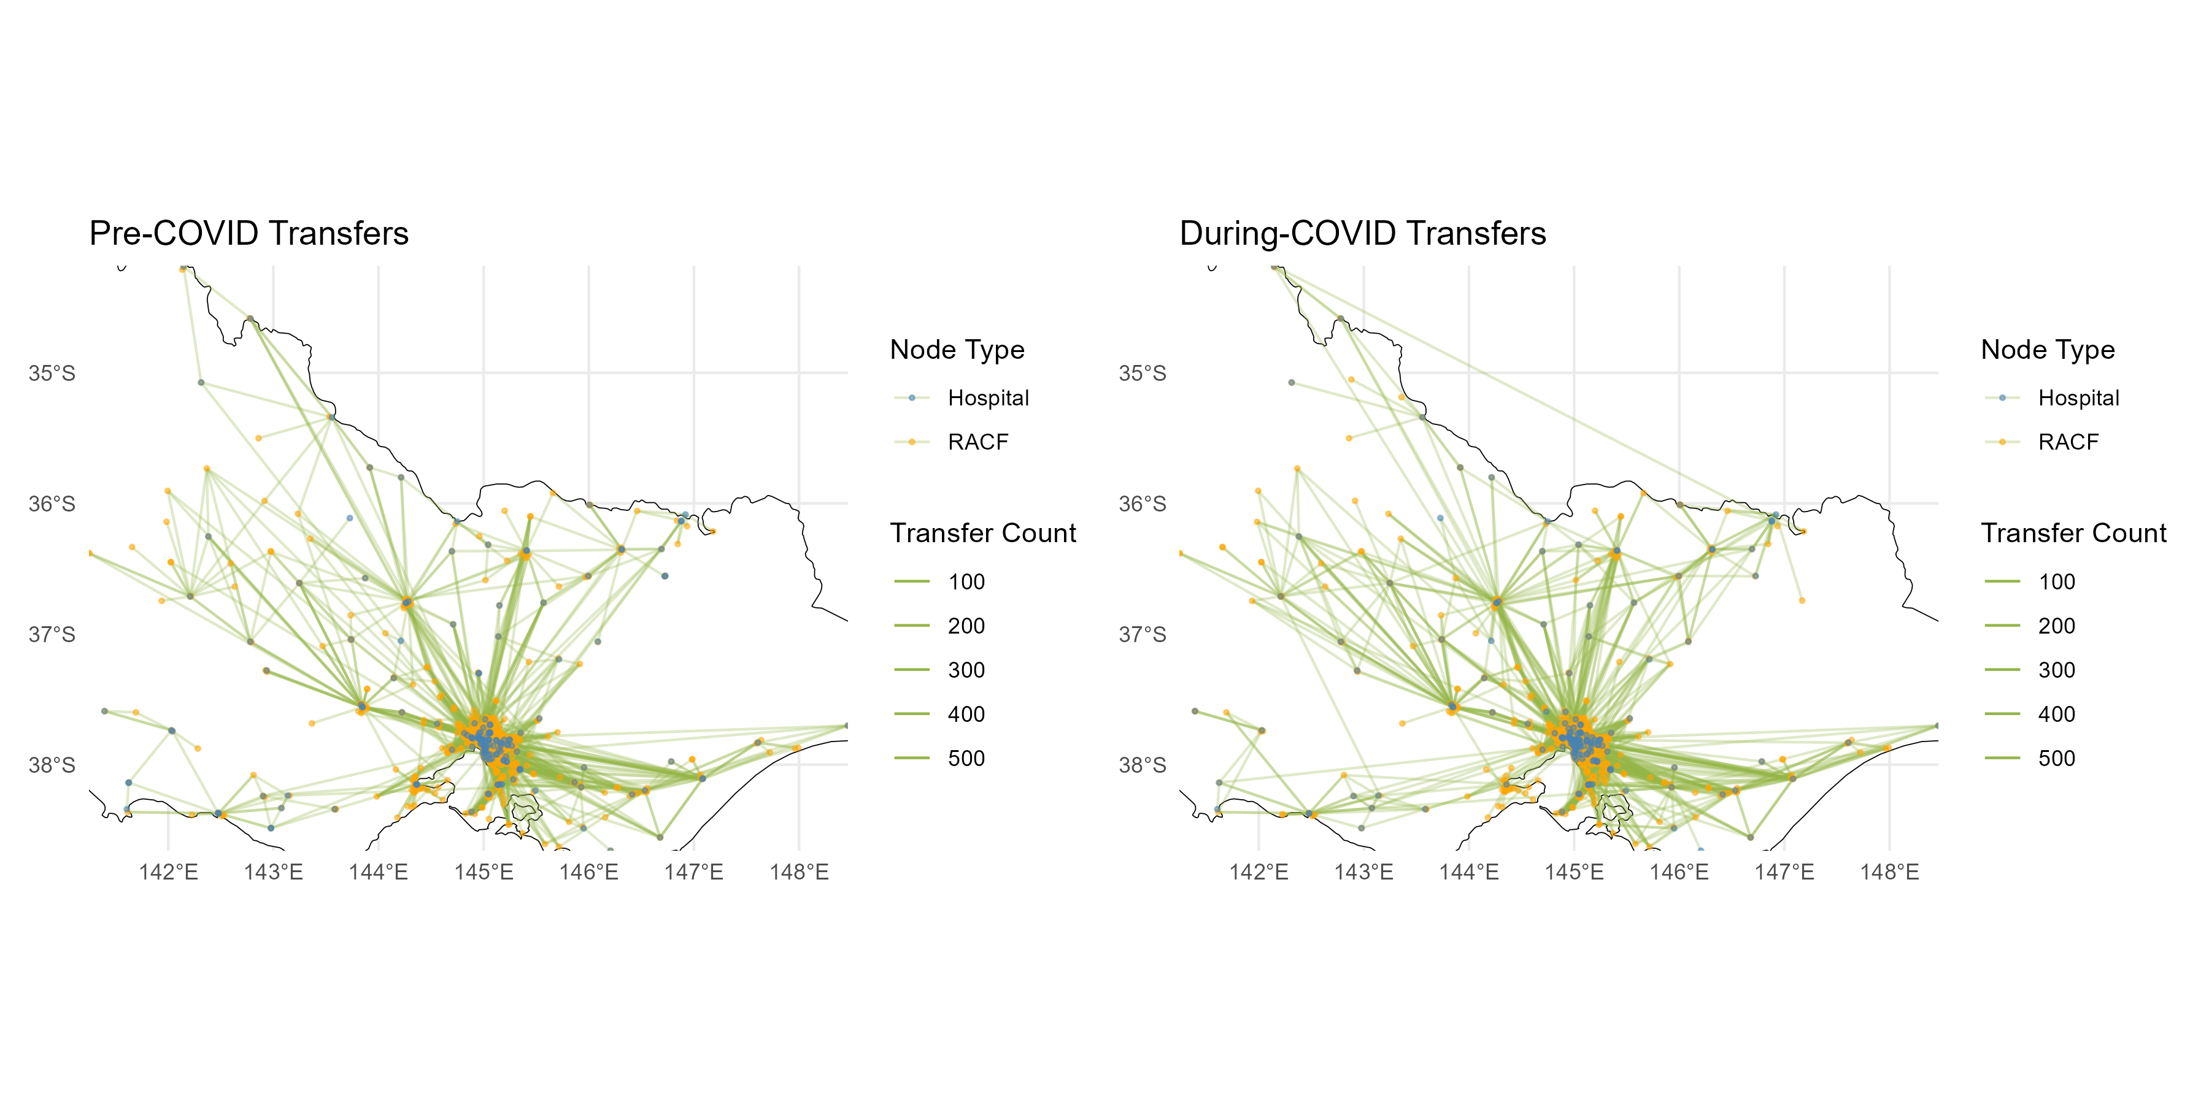

*Figure 11: Comparison of transfer network before and during COVID period*

Figure 10 and 11 show comparative visualization of transfer networks across two dimensions: weekday vs weekend and pre-COVID vs during-COVID. Each plot maps the aged care transfer network in Victoria, with nodes representing hospitals and RACFs, and edges indicating the volume of transfers, scaled by thickness.

Compared with weekday transfers, weekends transfers show a clear reduction in overall activity: the network is sparser, edges are thinner, and fewer RACF-hospital pairs remain active. This supports the earlier EDA finding that transfers drop significantly during weekends, likely due to operational and scheduling limitations.

While both pre-COVID and during-COVID transfer networks appear broadly similar in structure, featuring dense connections between major hospitals and surrounding RACFs, there are minor shifts in the periphery by inspection. During-COVID networks show slight increased concentration engagement from peripheral areas, suggesting a broader geographic spread of transfer activity. This is possibly due to outbreak management, regional hospital pressure, or altered triage protocols

However, by only inspection, the difference of pattern can hardly be captured accurately. Adjacency matrices and heat maps are essential tools for identifying and visualizing changes in aged care transfer patterns across different time periods. The adjacency matrix represents transfer frequencies between RACFs and hospitals, capturing the structure and intensity of connections in the network. To ensure fair comparison across groups with unequal duration, mentioned previously in EDA, we apply standardization by dividing transfer counts by the number of days in each period and transforming values (using square root) to reduce skew from high-frequency transfers. By subtracting standardized matrices, we detect increases or decreases in transfers between specific locations. Heat maps then translate these differences into color-coded visualizations, enabling quick and intuitive identification of significant changes in network behavior. This method supports evidence-based understanding of how aged care transfer dynamics respond to temporal or systemic factors.

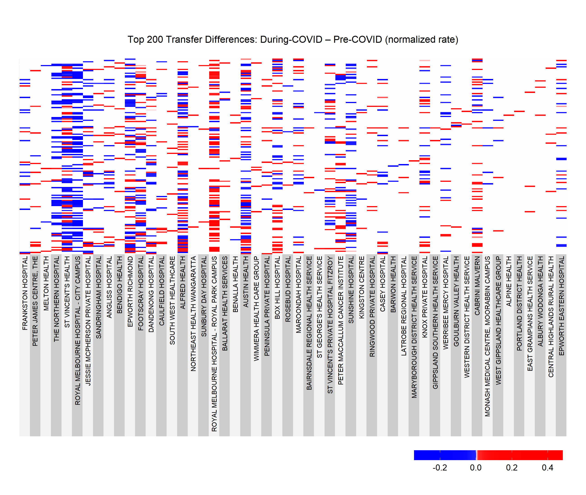

*Figure 12: Heat map of transfer difference before and during COVID period*

Figure 12 visualizes changes in transfer patterns between Residential Aged Care Facilities and hospitals during the COVID-19 period compared to the pre-COVID period. Each cell represents a transfer from a specific RACF (row) to a hospital (column), with color indicating the direction and magnitude of change-red for increased transfers, blue for decreased transfers, and white for no change or masked low-activity pairs. The adjacency matrices used to construct the heat map ensure that all locations are represented with consistent dimensions and ordering, allowing for meaningful visual comparison. Only the top 200 most significant changes are shown to highlight the most impacted transfer links, making it easier to detect patterns such as hot spots of increased hospital demand or reduced mobility during the pandemic. This plot shows mixed red and blue patches, indicating both some increase and decrease before and after COVID, as their number of transfers are similar obtained in previous section. There is a noticeable shift: transfers to the Royal Melbourne Hospital City Campus dropped sharply, while transfers to its Royal Park Campus increased. This redistribution aligns with events during the COVID-19 outbreak in 2020, when the Royal Park campus was repurposed to manage aged care residents and COVID-positive patients (ABC News, 2020). At the same time, several wards at the City Campus were closed to contain outbreaks and priorities acute and ICU care. In effect, what we see in the network is less about a fall in demand and more about a policy-driven rerouting of patients — Royal Park absorbed a large share of aged care transfers as part of the state’s infection-control strategy, while the City Campus focused on critical hospital care. This explains why the two campuses moved in opposite directions on the heatmap, reflecting deliberate systemic reconfiguration rather than random fluctuation.

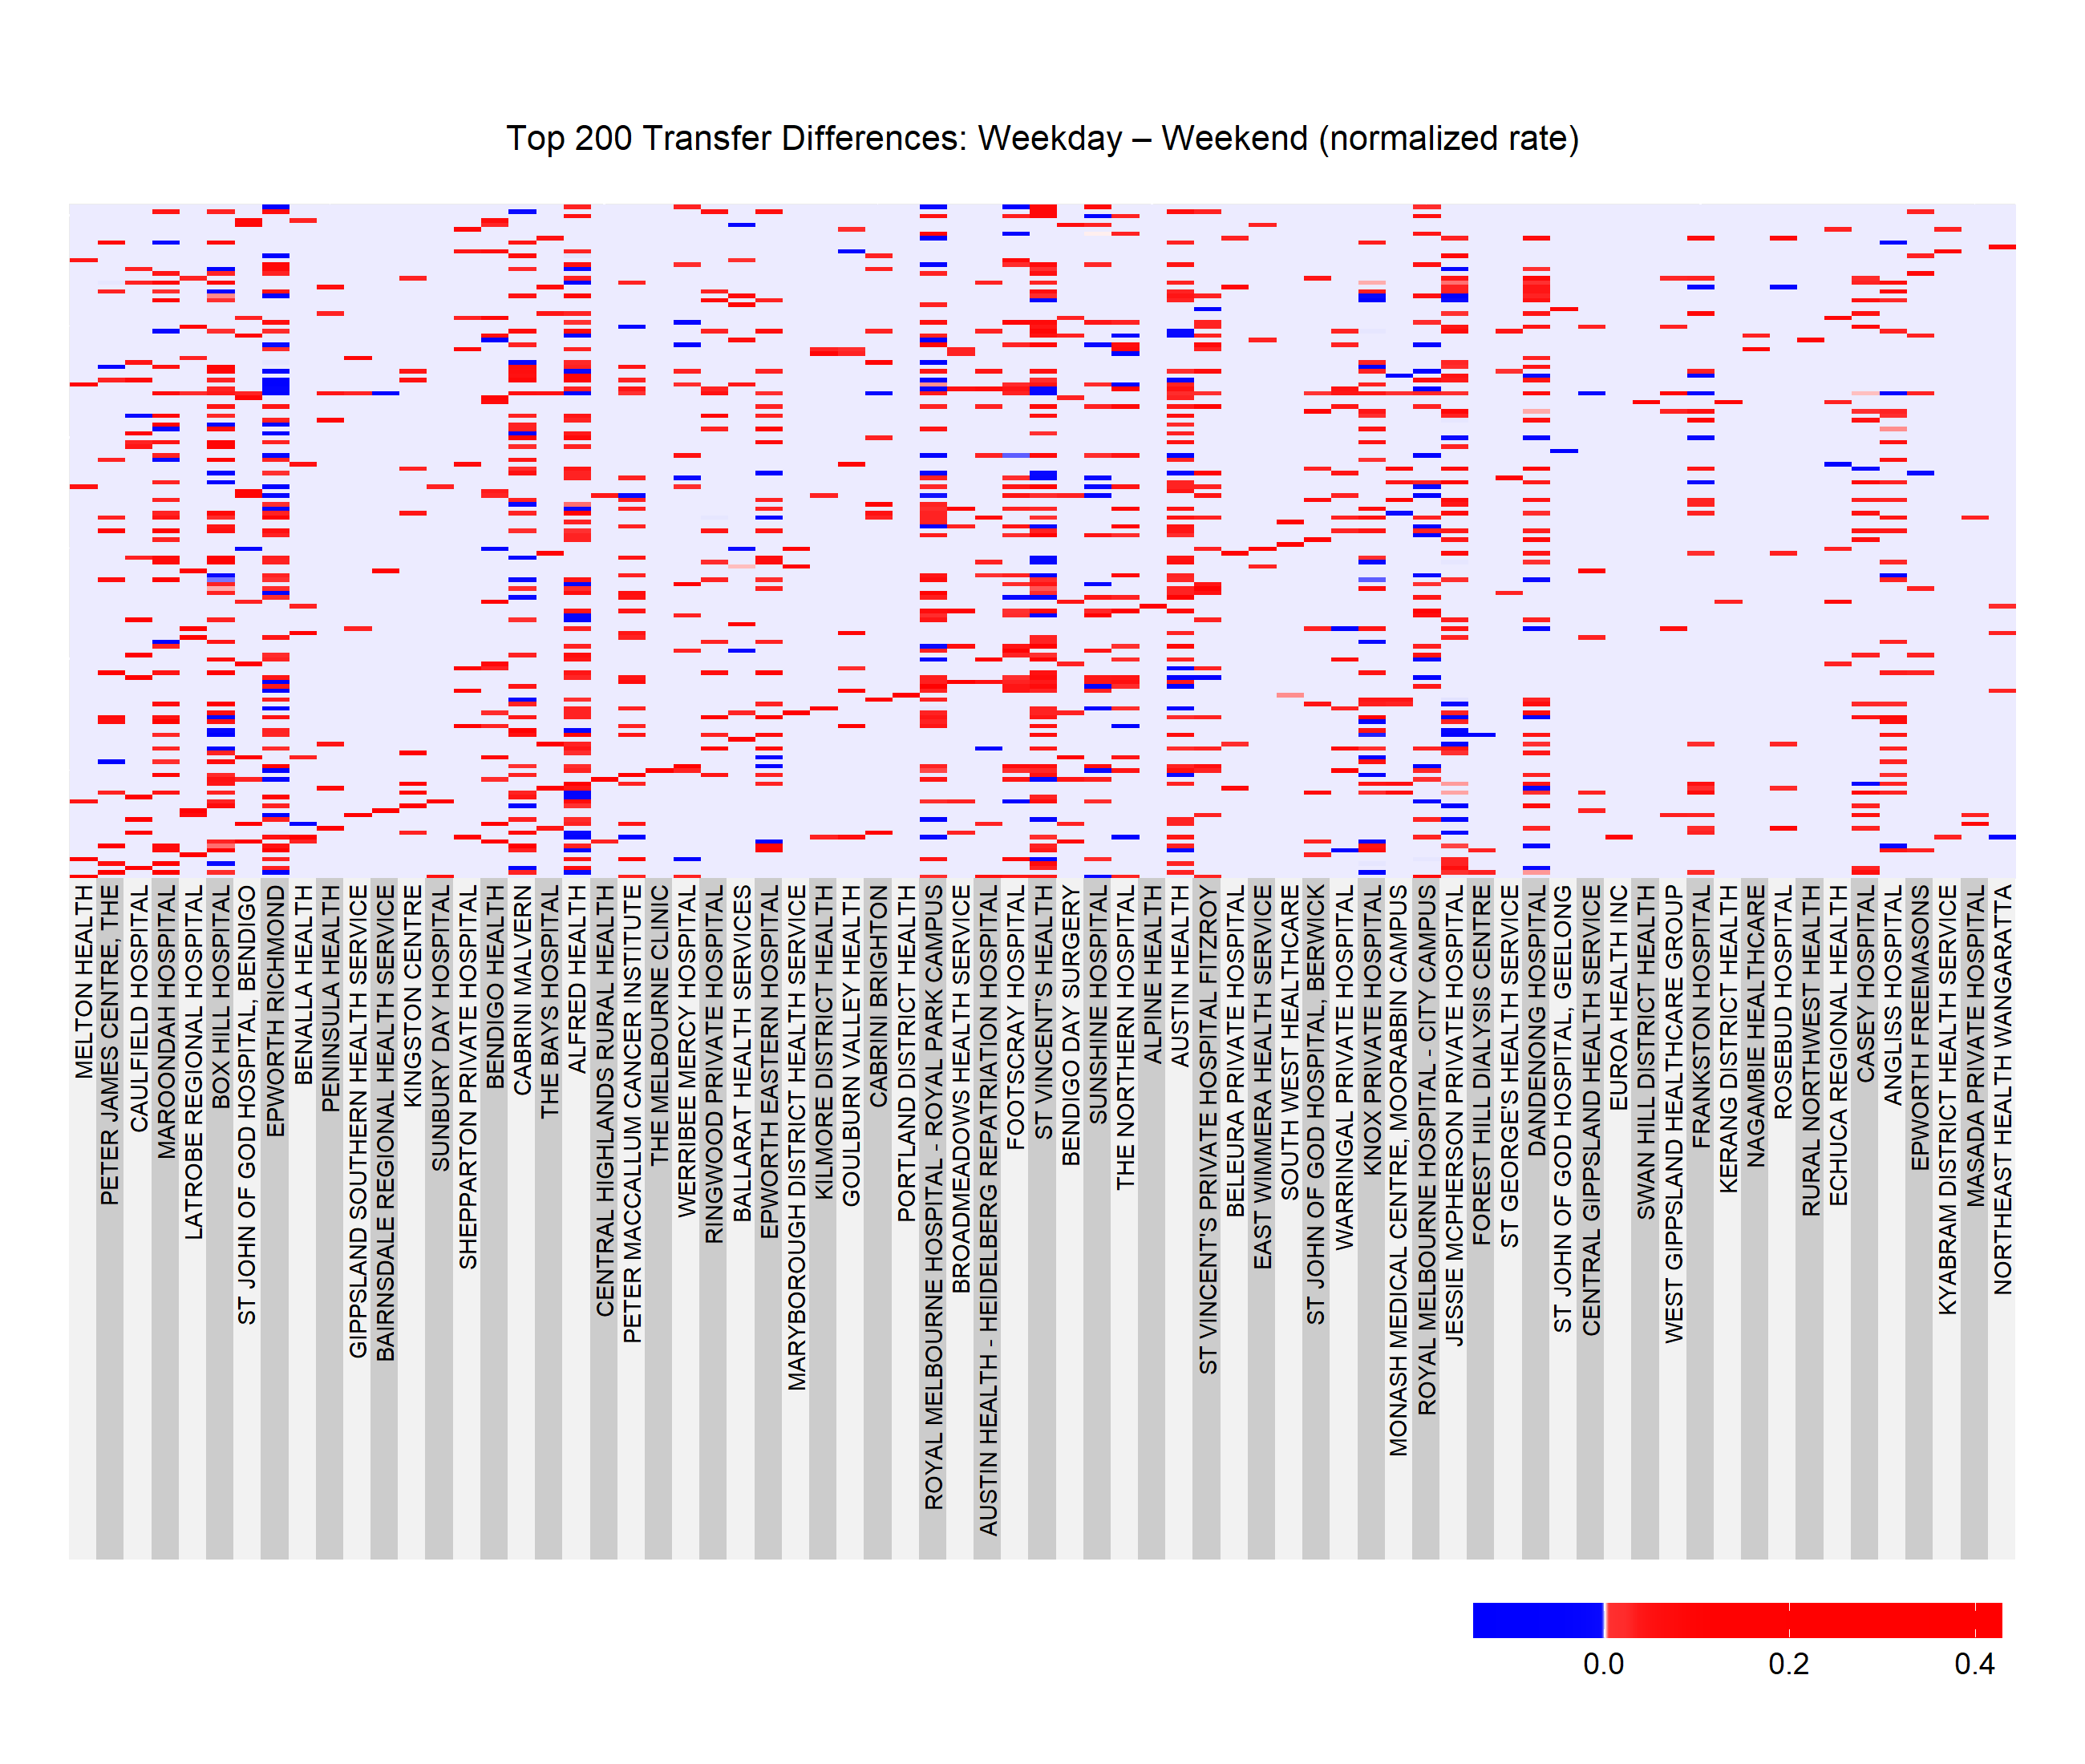

*Figure 13: Heat map of transfer difference between weekdays and weekends*

The difference of subtracting weekends transfers from weekdays transfers are shown in the Figure 13. The overwhelming prevalence of red cells across the heat map indicates that transfers significantly drop on weekends across most pairs. This supports earlier EDA results, suggesting lower system activity during weekends, possibly due to reduced staffing, limited scheduling capacity, or delayed hospital admissions. Blue cells are especially concentrated along the diagonal, suggesting that same-facility (self-loop or short-range) transfers drop more during weekends, which potentially reflecting deferrals in routine care or transport arrangements.

# Modelling

### 3.1 Model Selection

In the early stages of this project, gravity models and stochastic block models (SBMs) were identified as natural candidates for analysing aged care–hospital transfers. Both approaches are well grounded in healthcare network research, with gravity models capturing spatial interaction effects and SBMs uncovering latent community structures. However, when applied to the Victorian dataset, these models quickly proved computationally demanding. Fitting them on the full network required several hours to complete, making them impractical for a project with tight timeframes, particularly given the need to compare multiple temporal slices (e.g., pre- vs. during-COVID, weekday vs. weekend). This highlighted the tension between statistical sophistication and feasibility: while complex models may capture richer dynamics, their cost in processing time can constrain the ability to iterate, validate, and refine findings within the project’s scope.

To balance rigour with practicality, we therefore shifted towards generalised linear models (GLMs) as a more efficient modelling strategy. GLMs allow the relationship between transfer counts and explanatory factors to be estimated in a computationally tractable way, while still offering flexibility through distributional choices suited to count data. In particular, Poisson regression provides a baseline framework, and the negative binomial model can address potential over-dispersion, ensuring robustness of inference. By adopting this approach, the analysis remains interpretable, calculable to the full dataset, and adaptable for testing different covariates of interest. This pragmatic choice provides a clear and defensible methodological path: prioritising feasible yet robust estimation, while leaving open the option to return to more complex network-based models in future work once additional time and resources permit.

### 3.2 Model fit methodology

We began by narrowing the question to something concrete and comparable: transfers from residential aged care facilities (RACFs) to hospitals within metropolitan Melbourne. Each transfer was tagged by two simple, policy-relevant time labels: whether it occurred before or during COVID (split at 15 March 2020), and whether it happened on a weekday or weekend. To avoid biasing the analysis toward only busy pairs, we built a complete “grid” of all RACF–hospital combinations across these time labels, explicitly including pairs that recorded zero transfers. This creates a fair playing field where absences of flow are treated as information, not missing data.

Because the state-wide network is large, we then focused the analysis on a manageable but representative “core” sub-network. Hospitals were ranked by total volume and the five busiest were kept, with Royal Melbourne Hospital (City Campus) always included due to its central role. On the RACF side, we chose origins that were clearly influential according to three intuitive lenses: those that frequently send to RMH, those with the largest overall transfer volumes, and those with strong links to multiple top hospitals. Bringing these lenses together produces a shortlist of RACFs that matter operationally, while keeping the modelling stable and interoperable.

Transfer counts are non-negative integers, so we modelled them with generalised linear models designed for count data. We started with a Poisson model as the baseline, relating transfer intensity to COVID period, weekday/weekend, the origin RACF, and the destination hospital. Because real-world counts often show more variability than the Poisson allows, we also fit a negative binomial model that can flex to extra variability and let the COVID effect differ by RACF (so facilities can shift differently across the pandemic). Finally, to account for the many RACF–hospital pairs that very rarely exchange patients, we tried a zero-inflated variant that explicitly allows for “structural zeros.” Together, these specifications balance realism (capturing dispersion and rare flows) with speed and clarity.

Models were judged on two fronts. First, we compared standard information criteria (AIC/BIC) and log-likelihoods to see which specification strikes the best fit–parsimony trade-off. Second, we checked practical diagnostics: are predictions close to observed counts across the range (not just at the mean)? Do residuals look well-behaved across COVID vs pre-COVID and weekday vs weekend? These visual checks help spot under- or over-prediction in specific subgroups and reveal whether key patterns are being missed.

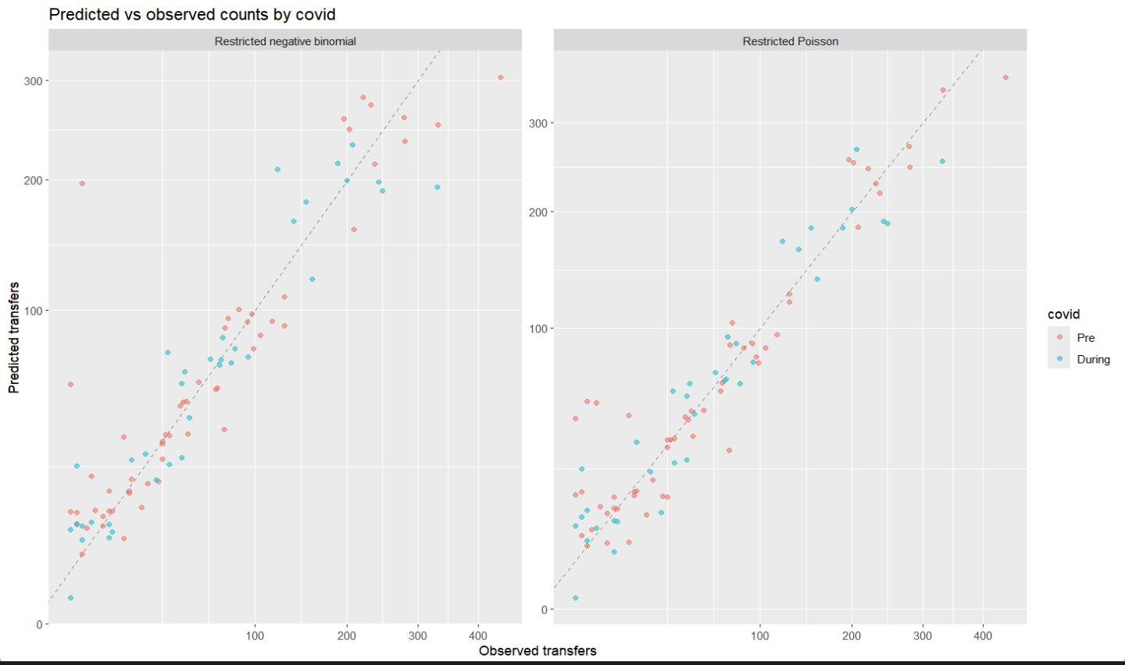

*Figure 14: Predicted results comparison for two models- negative binomial vs Poisson under oviduct effect*

To ensure findings weren’t driven by extremely sparse cells, we repeated the Poisson and negative binomial fits after filtering out combinations with very small counts. This simple sensitivity analysis often stabilises dispersion estimates and confirms whether the main conclusions hold when the “noisy tail” is trimmed.

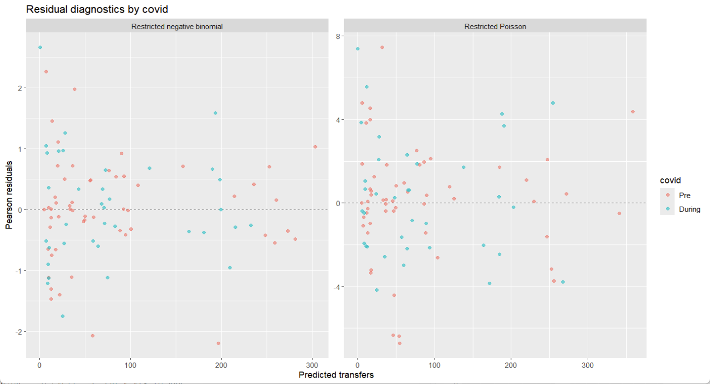

*Figure 15: Residuals comparison for two models- negative binomial vs Poisson under covid effect*

Lastly, we asked the most important question for planning: how well do the models generalise to unseen weeks? We ran a leave-one-week-out cross-validation, refitting the preferred model on all weeks except one and predicting that held-out week. We evaluated errors (RMSE and MAE), a probabilistic score tailored to the negative binomial, and compared observed vs predicted weekly totals over time. This provides an honest, operational read on whether the model tracks real fluctuations and where it might drift, giving confidence that the final choice is both defensible and useful.

Overall, the approach is deliberately pragmatic: a carefully chosen sub-network, simple but appropriate count models, transparent comparisons, and out-of-sample checks. The analysis uses cells with more than two transfers and includes ninety-one combinations.It trades some theoretical complexity for timely, robust insights—while leaving the door open to revisit heavier network models once time and computing budgets allow.

### 3.2 Model selection

The predicted-versus-observed GLM plots show a healthy pattern. Most points fall close to the 45-degree line. The fit tracks the data from low to high counts. A few points stray at the extremes. The overall alignment still looks strong.

The colour mapping shows a stable mix across periods. The points for both periods overlap well. The plot does not suggest a clear period bias. The central trend remains intact.

The residual plots tell a consistent story. The residuals centre on zero. Most values sit between minus two and plus two. The band is tight for mid-range predictions. The spread is larger when predicted counts sit near zero to two transfers. That pattern is common for discrete counts. The band stays reasonably even at higher predictions.

These plots together support a sound GLM fit. The predictions follow the data closely. The residuals behave well around zero. The extra noise at very small counts deserves caution. The model still looks reliable for inference and planning.

It is hard to tell by only looking into plots to find a better model. Computing the diagnostic criteria, the negative binomial model achieves an AIC of 868. The competing Poisson model has an AIC of 1257. The BIC values tell the same story. The negative binomial BIC is 938, while the Poisson BIC is 1324. The log-likelihood also improves. The negative binomial reaches minus 406, compared with minus 601 for Poisson.

These results show a decisive advantage for the negative binomial. The data display extra variability that a Poisson model cannot handle. The negative binomial includes a dispersion term. That term absorbs the excess variance. The fit then improves across origin–destination pairs and time slices. The residual patterns become more stable.

This improvement is not driven by rare zero counts. The dataset already excludes very small cells. The gap therefore reflects real overdispersion in positive counts. The negative binomial captures this reality. The Poisson forces a mean equals variance rule that does not hold here.

By cross validating the negative binomial GLM, the results in Figure 15 align with the criteria selection. Look into the CV metrics, the log score measures probabilistic accuracy. Higher is better, so less negative is good. The series sits around minus 1.4 with small swings. A few dips reach about minus 1.8. Those dips mark shock weeks when behaviour changed fast. The overall line stays tight. The model is usually well calibrated.MAE shows the average absolute error per cell per week. Lower is better. Most weeks sit between 0.6 and 1.0 transfers. Some weeks climb to about 1.3. Those peaks are short and isolated. Typical error is small and stable. RMSE punishes larger misses. Most values lie near 0.9 to 1.4. A few spikes reach around 2.3. These spikes likely align with rapid system shifts. The baseline remains close to 1.0. The pattern supports consistent out-of-sample accuracy. Theta is the negative binomial dispersion. Larger theta means less overdispersion. The values are high and steady near the same level each week, with rare jumps. This says the variance structure is stable at the weekly scale. The model behaves close to Poisson in calm weeks, but it still has room to absorb extra spread when shocks occur.

The diagnostics point to a good fit. Errors are modest and steady across weeks. Probabilistic scores are stable. Dispersion estimates are consistent. Short spikes appear when the system changes abruptly, which is expected. For planning and short-term forecasting, this performance is reliable. Further gains, if needed, would come from adding simple time effects around known shock periods.

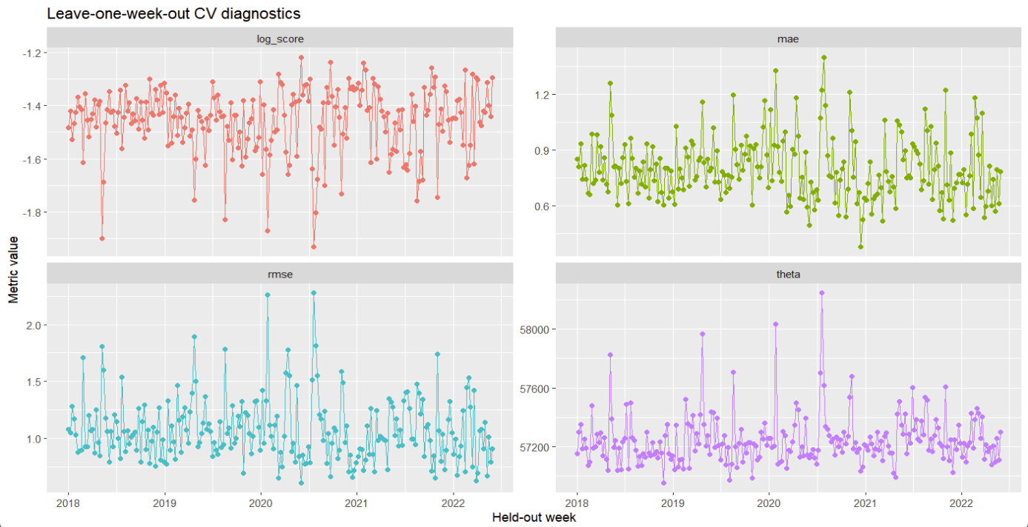

*Figure 16: Cross validation of NB GLM metrics*

The cross-validated residual plot in Figure 17 looks mostly healthy. Most points sit near zero, which signals fair calibration. The wedge shape widens as predictions grow, which matches count data where variance rises with the mean. The cloud leans slightly below the zero line. That lean means small over-prediction on average, especially at mid to high predicted counts. The fit is therefore good but not perfect. We could reduce the negative skew by adding other time structure such as month or quarter effects. We could add pair-level random effects and expend the sub data set into the whole data to capture unobserved ties between facilities and hospitals, although it will take much more time. We can also include distance or travel time as covariates and add a lag of past transfers to soak up short-term momentum. Any of these steps can be taken to trim the bias but may increase model complexity and make the project out of scope.

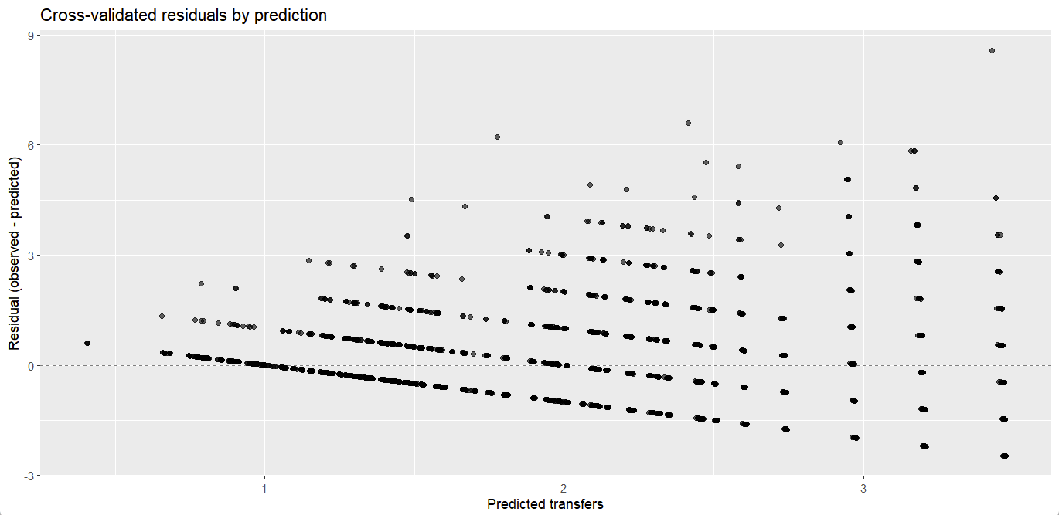

*Figure 17: Cross validation of NB GLM residual plot*

Therefore, project will adopt the negative binomial GLM as the main specification. The model balances fit and simplicity better than the alternative, with alignments of operational knowledge about heterogeneous flows. The model provides a sound base for inference and forecasting.

### 3.3 Modelling results

The negative binomial GLM model uses a log link, with each coefficient shifts the expected transfer count on a multiplicative scale. The distribution and link:

$$Y_{i}\sim NegBin(u_{i} ,θ), logu_{i}=η_{i}$$

The intercept sets the baseline for a reference RACF, a reference hospital, pre-COVID, and weekday. The intercept equals 5.555 on the log scale. That value implies about 259 transfers for the reference case.

The COVID indicator shows a clear drop. The coefficient for “During” equals −0.266. That value corresponds to a rate ratio of 0.77. Transfers during COVID are about 23 percent lower than pre-COVID, holding other factors fixed.

The weekend effect is strong. The coefficient equals −1.029. That value gives a rate ratio of 0.36. Weekend transfers are roughly 64 percent lower than weekday.

RACF effects vary widely. Several origins show large positive offsets. For example, Plenty Road Bundoora has a coefficient near 2.946, which is about 19 times the reference RACF. Willandra Drive Epping sits near 2.916, which is about 18 times the reference. The Strand Moonee Ponds sits near 1.760, which is about six times the reference. Other RACFs show negative offsets. Burton Avenue Clayton sits near −3.329, which is about three percent of the reference. Young Road Hallam sits near −1.272, which is about 28 percent of the reference. These patterns point to strong heterogeneity across facilities.

Hospital effects are also distinct. The coefficients are relative to a reference hospital. Austin Health sits near −1.023, which is about 0.36 times the reference. Box Hill Hospital sits near −0.866, which is about 0.42 times the reference and is only marginally significant. Dandenong Hospital sits near −1.348, which is about 0.26 times the reference. Royal Melbourne Hospital City Campus sits near −3.407, which is about 0.03 times the reference. The Northern Hospital sits near −2.939, which is about 0.05 times the reference. These ratios reflect systematic differences in flows after accounting for RACF, period, and day type. The linear predictor:

$$η_{i}=β_{0}+β_{covid}1\left\{{Druing}_{i}\right\}+β_{weekend}1\left\{{Weekend}_{i}\right\}+\sum_{j∈ℱ\backslash f_{0}}{β_{from,j}1\left\{{from}_{i}=j\right\}+\sum_{h∈ℋ\backslash h}{β_{to,k}1\left\{{to}_{i}=k\right\}}}$$

All resutls of rate ratios are shown in Appendix 4-6, and expressing model outputs in this way renders the results directly actionable. Converting rate ratios to expected counts produces planning numbers in practice, also shown in Appendix 7. For a high-volume corridor—weekday, pre-COVID transfers from Plenty Road Bundoora to Austin Health—the expected count is 259 × 19.0 × 0.36 ≈ 1,770 transfers per week, indicating a very high level of activity under these conditions. By contrast, for a low-volume corridor—weekend, during-COVID transfers from Burton Avenue Clayton to the Royal Melbourne Hospital City campus—the expected count is 259 × 0.77 × 0.36 × 0.036 × 0.033 ≈ 0.08 transfers per week, which is roughly one transfer every 12–13 weeks.

In general, the negative binomial GLM fits these data well. The model handles extra variability. The information criteria are lower. The residuals look stable. The out-of-sample checks are reasonable. The estimates are clear. The COVID period reduces expected transfers. Weekends reduce transfers even more. Some RACFs send many more patients than others. Some hospitals receive far fewer than the reference site. The network shows strong heterogeneity.

These results can have potential uses. Health services can plan staffing around weekday–weekend gaps. Ambulance teams can expect lighter weekends and heavier mid-week peaks. Hospitals can target high-volume RACFs and streamline referrals. Managers can monitor the main corridors that carry most flows.

The model also supports early warning. Planners can flag sudden deviations from expected counts. Infection control can watch high-volume links during outbreaks. Policy staff can test simple scenarios by changing period and day settings. The project will use the negative binomial GLM for inference and short-term forecasting.

# Discussion

This study provides one of the first systematic examinations of aged care–hospital transfer networks in Victoria using Ambulance Victoria data. By combining exploratory network analysis with statistical modelling, the research highlights the structure of transfers, temporal variations, and key institutional roles. The results demonstrate clear heterogeneity across facilities and hospitals, with certain RACFs and hospitals acting as central hubs. Transfers decreased substantially during weekends and fell further during the COVID-19 period, although this decline varied across institutions. Importantly, the negative binomial generalised linear model was identified as the most suitable statistical framework, providing a balance between computational efficiency, interpretability, and robustness.

While the findings strengthen our understanding of aged care transfers, several limitations must be acknowledged. First, the dataset, although large, contains inconsistencies such as missing or ambiguous facility names, misclassified addresses, and small numbers of implausible records. These issues required filtering and careful interpretation, but residual errors may remain. Second, the analysis was restricted to a core sub-network to ensure computational tractability. While this approach allowed for clear and timely results, it inevitably excluded peripheral RACFs and hospitals that may contribute to the broader dynamics of the network. Third, the models included only a limited set of covariates—COVID period, weekday versus weekend, origin RACF, and destination hospital. Other potentially important drivers, such as distance, travel time, patient condition, or staffing levels, were not incorporated, which may explain some of the residual bias observed in cross-validation. Finally, the cross-sectional treatment of the data may understate dynamic feedbacks in the system. Transfers during one week may influence flows in subsequent weeks, particularly during outbreaks, but this temporal dependency was not explicitly modelled.

These limitations suggest several directions for future improvement. Data quality can be strengthened by matching facility addresses with verified lists of hospitals and aged care homes. This step would reduce errors and make facility classification more reliable. Expanding the analysis to include the entire statewide network would also provide a more complete view of transfer patterns, though this will require greater computing power or more efficient model structures. Adding richer variables, such as distance, travel time, and patient characteristics, could help explain differences in transfer behaviour and reduce remaining biases in the model. Future models could also include time-based effects by using autoregressive terms or dynamic network approaches to capture how transfer patterns change over time. Another promising extension would be to simulate disease transmission directly on the network, helping to identify high-risk connections during outbreaks.

Overall, this project shows that network-based modelling of aged care transfers is both practical and informative. The negative binomial GLM offers a solid starting point for understanding transfer behaviour and guiding policy decisions. It can help identify key transfer corridors and reveal system weaknesses. To build on this foundation, future work should focus on cleaner data, wider network coverage, and more detailed modelling of time and space. These improvements will deepen our understanding of how aged care and hospital systems interact and will support better planning for both operations and infection control.

# Conclusion

This project explored the patterns of transfers between aged care facilities and hospitals in Victoria using data from Ambulance Victoria. The results showed that transfers are not random. Instead, they follow clear and consistent patterns, with some RACFs and hospitals acting as major hubs in the network. Transfer activity dropped on weekends and declined further during the COVID-19 period, although the size of the change differed between locations. The negative binomial generalised linear model proved to be the best-fitting option. It handled the extra variation in the data well and produced stable results across different time periods.

The findings provide both practical and broader insights. Health services can use this information to plan staff rosters, manage weekday and weekend differences, and monitor busy transfer routes. Ambulance services can prepare for peak periods, while hospitals can strengthen referral links with high-volume RACFs. However, the analysis also showed some gaps in the data and methods. Unclear facility names, the exclusion of smaller sites, and the lack of variables like distance or patient type suggest that future work should build on a cleaner and more detailed dataset with stronger modelling tools.

In conclusion, this study demonstrates that network-informed modelling of aged care transfers is feasible, interoperable, and valuable for policy and planning. It provides a foundation for future research to expand coverage, refine models, and simulate infection risks. By strengthening this work, the aged care sector can move closer to safer, more resilient systems that better protect vulnerable residents.

Reference  
Donker, T., Wallinga, J., & Grundmann, H. (2010). Patient referral patterns and the spread of hospital-acquired infections through national health care networks. PLoS Computational Biology, 6(3), e1000715.

Donker, T., et al. (2012). Hospital networks and the risk of hospital-acquired infections. Journal of the Royal Society Interface, 9(76), 2648–2656.

Assab, R., et al. (2017). Healthcare-associated infection transmission across networked hospital settings. BMC Medicine, 15(1), 157.

Newman, M. E. J. (2010). Networks: An Introduction. Oxford University Press.

Pei, S., Morone, F., Liljeros, F., Makse, H., & Shaman, J. L. (2018). Inference and control of the nosocomial transmission of methicillin-resistant Staphylococcus aureus. eLife, 7, e40977. [https://doi.org/10.7554/eLife.40977](https://doi.org/10.7554/eLife.40977" \t "_new)

ABC News. (2020, August 14). Coronavirus outbreak forces closure of Royal Melbourne Hospital wards. Australian Broadcasting Corporation. [https://www.abc.net.au/news/2020-08-14/coronavirus-outbreak-royal-melbourne-hospital-wards-close/12556622](https://www.abc.net.au/news/2020-08-14/coronavirus-outbreak-royal-melbourne-hospital-wards-close/12556622" \t "_new)

# Appendix

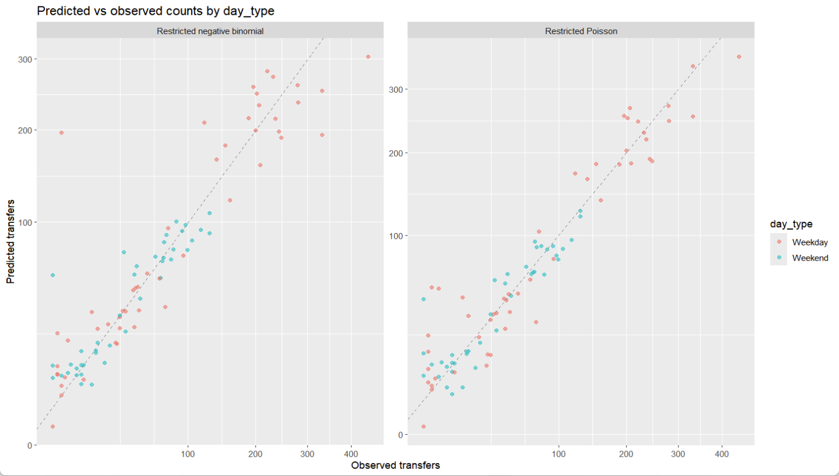

*Appendix 1: Predicted results comparison for two models- negative binomial vs Poisson under weekday/weekend effect*

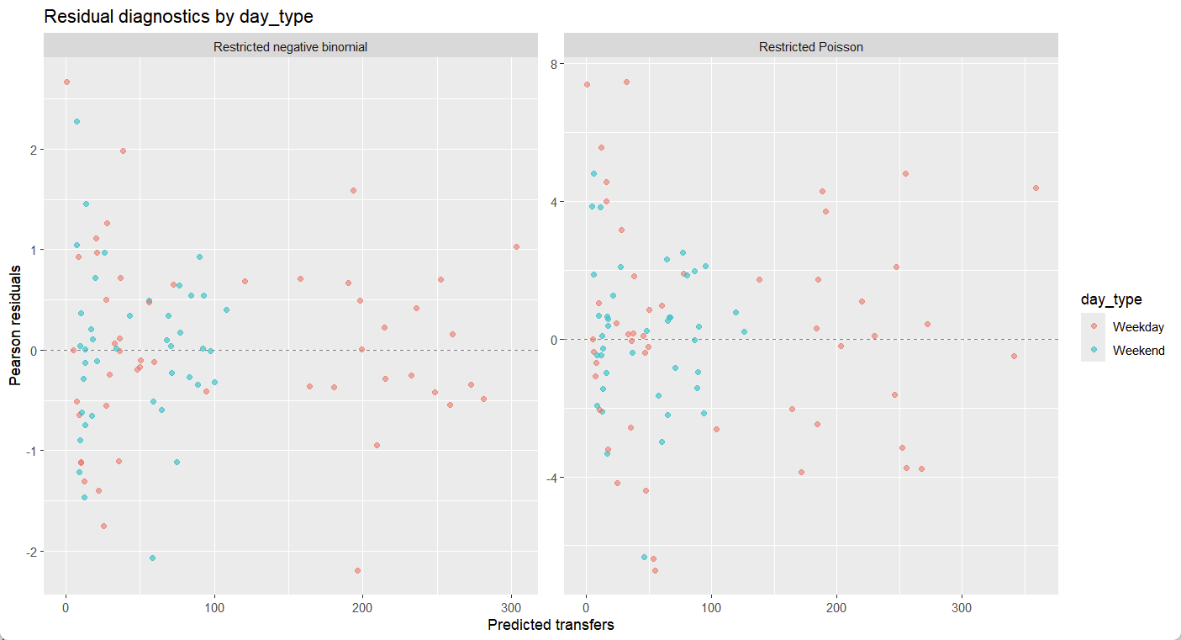

*Appendix 2: Residuals comparison for two models- negative binomial vs Poisson under weekday/weekend effect*

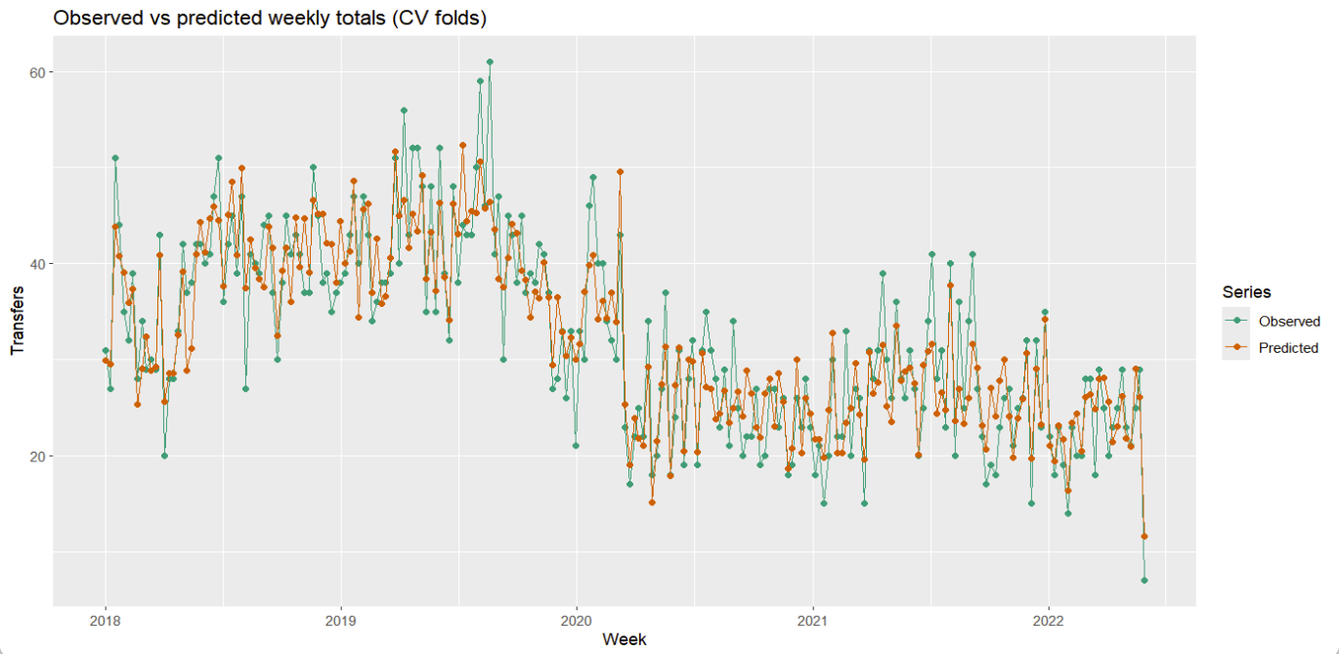

*Appendix 3: Predicted results vs actual observations by cross validation*

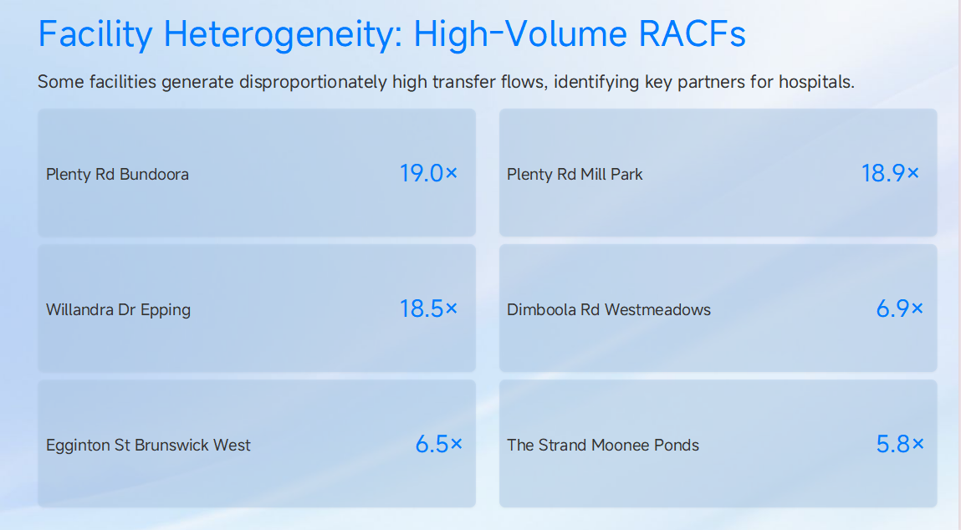

*Appendix 4: Rate ratios of high-vloume RACFs*

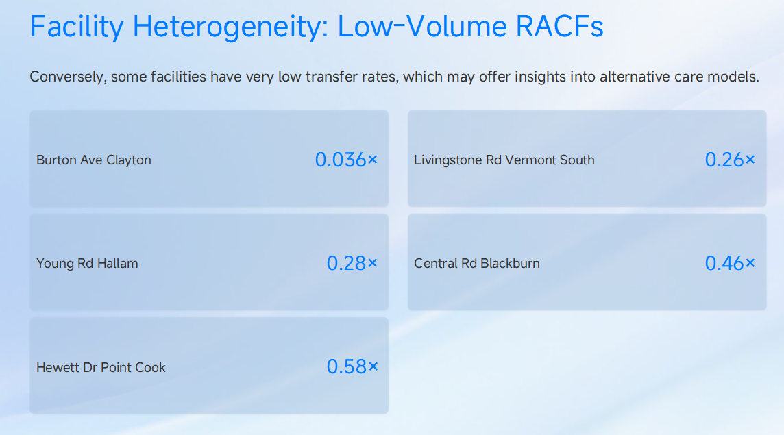

*Appendix 5: Rate ratios of low-vloume RACFs*

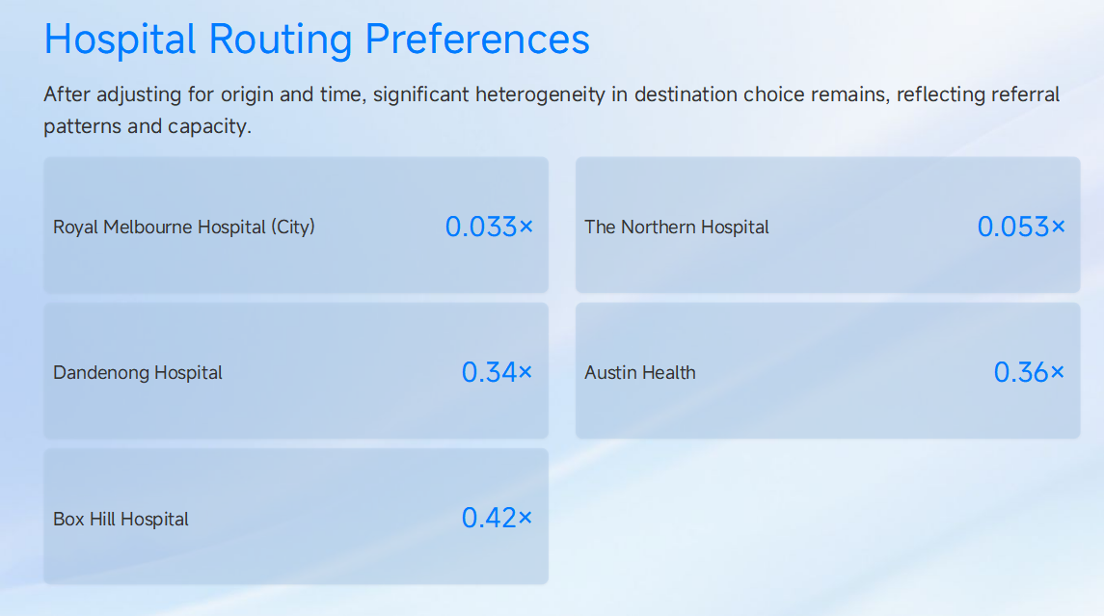

*Appendix 6: Rate ratios of selected hospital*

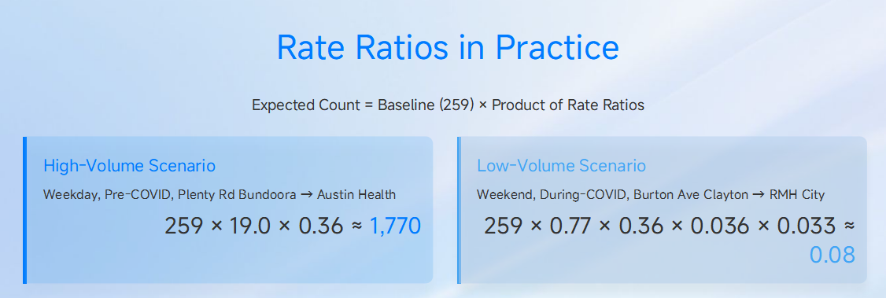  
*Appendix 7: Rate ratios applications*